Greater Glendive Community Foundation
Box 1122, Glendive, MT 59330
www.greaterglendive.org
Building a Sustainable Future for Dawson County

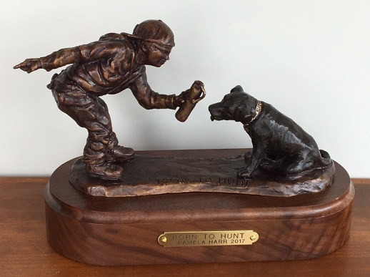
Bridger Bronze will make a limited edition of 200 miniature bronzes 6 3/4" x 9 1/2 x 4" on a black walnut base, priced at $995, the standard price. During 2017 Pam will donated 60% of all sales of this Born to Hunt sculpture to funding of the sculpting, casting bronze and installation of the life-sized sculpture. Bronzes can be ordered by calling 406-939-2686, ggcf@midrivers.com, GGCF Box 1122 Glendive, MT or contact Pamela Harr at Bridger Bronze at 406-687-3743.
Thanks for your support.

Name____________________________________________________________
Address__________________________________________________________

Email____________________________________________________________
Phone___________________________
Payment check#__________________________________________________________
Allow four to five weeks for delivery. Will you pick up or will we deliver? If mailing add $20
Mailing address_________________________________________
______________________________________________________
You can customize the 2nd line on the gold plaque on the walnut base. Born to Hunt ( line one)
(some say “In memory of Ty John Milne” ___________________________________________________________________________
Is this a gift?_______ Is it anonymous?
How would you like the listing honoring the donors?______________________________________________

GGCF Board of Directors: Peggy Iba, Kathy Ackerman, Deb Toepke, Angie Hagen, Pam Feisthamel, Keith Robinson
www.greaterglendive.org

